[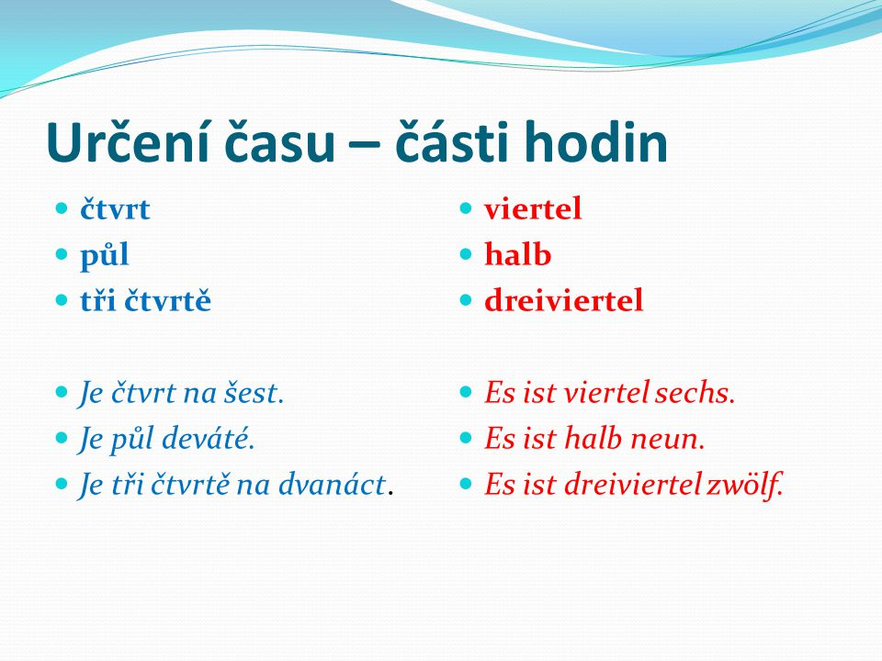](https://www.google.com/url?sa=i&rct=j&q=&esrc=s&source=images&cd=&cad=rja&uact=8&ved=0ahUKEwi4pLe6qbLZAhVBU1AKHdPoBaUQjRwIBw&url=http%3A%2F%2Fslideplayer.cz%2Fslide%2F2321656%2F&psig=AOvVaw0toL1Q35i4FPGjObh3y-oS&ust=1519141121880750)[](https://www.google.com/url?sa=i&rct=j&q=&esrc=s&source=images&cd=&cad=rja&uact=8&ved=0ahUKEwj1_ObQqbLZAhVJUlAKHZpkC60QjRwIBw&url=http%3A%2F%2Fslideplayer.cz%2Fslide%2F2321656%2F&psig=AOvVaw0toL1Q35i4FPGjObh3y-oS&ust=1519141121880750)

[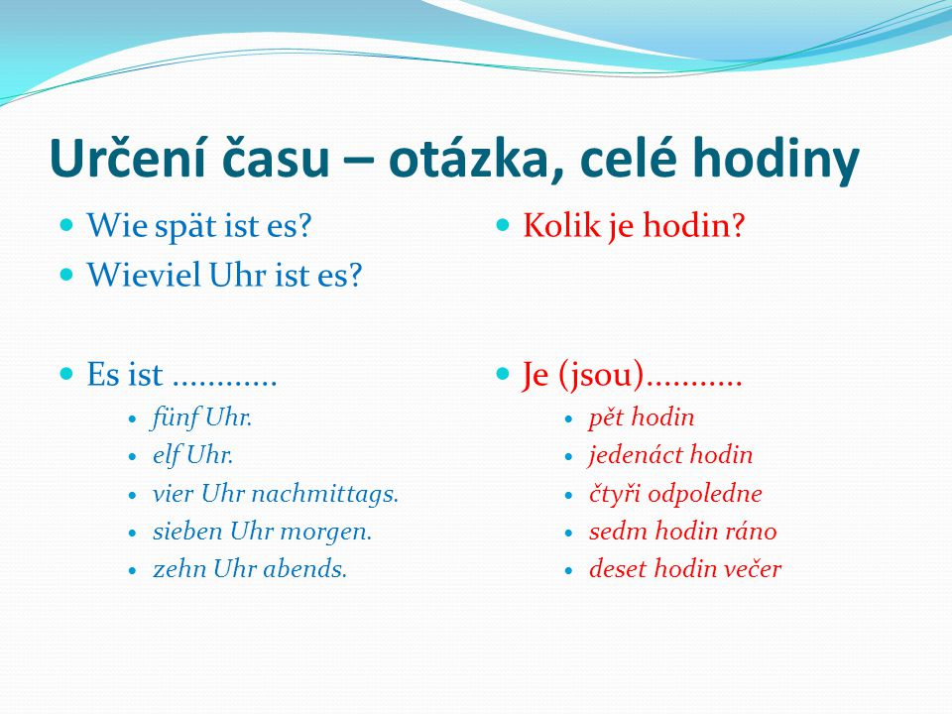](https://www.google.com/url?sa=i&rct=j&q=&esrc=s&source=images&cd=&cad=rja&uact=8&ved=0ahUKEwi979H0qbLZAhWQblAKHXh-C6cQjRwIBw&url=http%3A%2F%2Fslideplayer.cz%2Fslide%2F2321656%2F&psig=AOvVaw0toL1Q35i4FPGjObh3y-oS&ust=1519141121880750)