[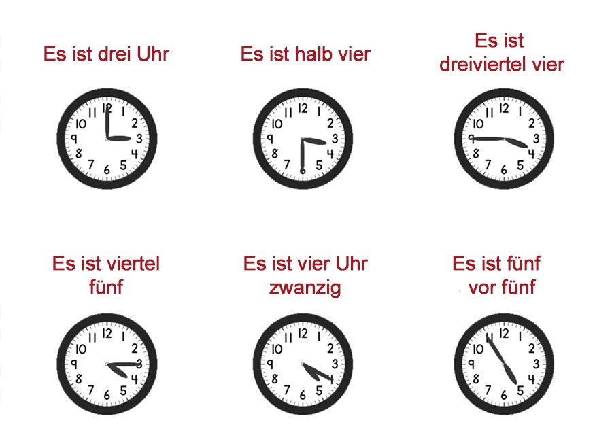](https://www.google.com/url?sa=i&rct=j&q=&esrc=s&source=images&cd=&cad=rja&uact=8&ved=0ahUKEwjFm9D9p7LZAhXKmLQKHaGfBKQQjRwIBw&url=https%3A%2F%2Fwww.milujemcestovanie.sk%2Fcas-po-nemecky%2F&psig=AOvVaw0toL1Q35i4FPGjObh3y-oS&ust=1519141121880750)